Girma Dingeto, CSD380 Module4.2 Assignment

Project: | Todo Application Functional Test Plan
Course: | CSD430 – Server-Side Development
Description: | Functional test plan validating core business requirements of the Todo web application
Date: | 2026/09/03

TABLE OF CONTENTS
Test 1 – Website Loads Successfully
Test 2 – Add a New Todo Item
Test 3 – Mark Todo Item as Complete
Test 4 – Delete a Todo Item
Test 5 – List Updates After Actions

Test 1 | Website Loads Successfully
 | Test Objective: Verify the Todo application loads through a standard URL and refreshes without errors | Developer: Girma  Date tested: 2026/09/03 | Peer tester: Ryan Barber  Date tested: 9/9/2026
Step | Action | Expected Results | Developer pass/fail | Tester pass/fail  + Screenshot
1 | Navigate to https://buwebdev.github.io/todo/ | Page loads without errors | Yes | Yes
2 | Observe the homepage | Todo list UI displays correctly | Yes | Yes
3 | Refresh the browser | Page reloads successfully | Yes | Yes  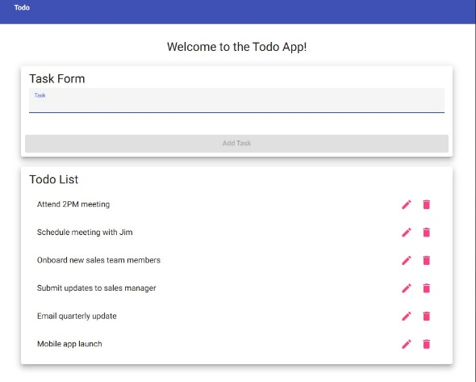
4 | Verify no console errors | No errors appear in browser console | Yes | Yes  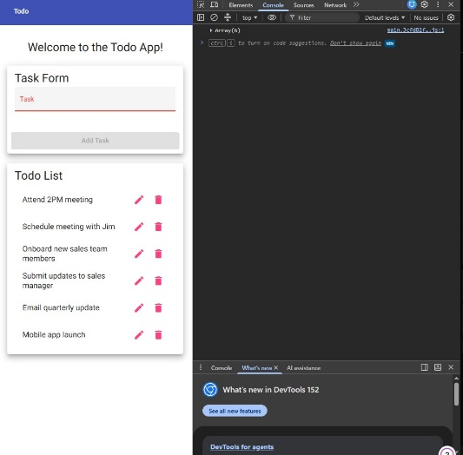
5 | Verify UI elements | Input field and Add button are visible | Yes | Yes
Comments | The application loaded correctly and behaved as expected during refresh. The UI elements appeared without delay, and no console errors were detected. Overall, the loading functionality meets the business requirement for standard URL access.

Test 2 | Add a New Todo Item
 | Test Objective: Verify users can add a new todo item | Developer: Girma  Date tested: 2026/09/03 | Peer tester: Ryan Barber  Date tested: 9/9/2026
Step | Action | Expected results: | Developer pass/fail | Tester pass/fail
1 | Locate the input field | Input field is visible | Yes | Yes
2 | Type “Buy groceries” | Text appears in input field | Yes | Yes  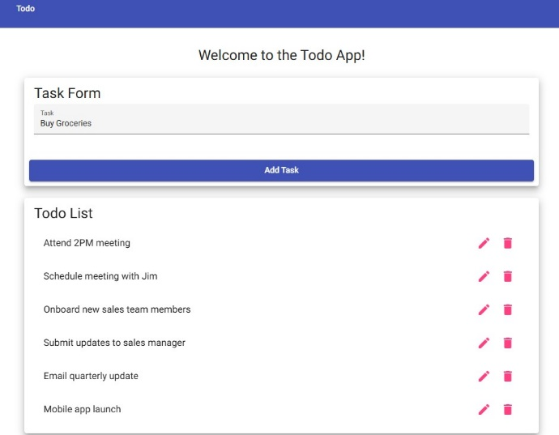
3 | Click the Add button | Item appears in the list | Yes | Yes
4 | Verify item placement | Item appears at bottom of list | Yes | Yes
5 | Verify no errors | No errors appear in console | yes | Yes  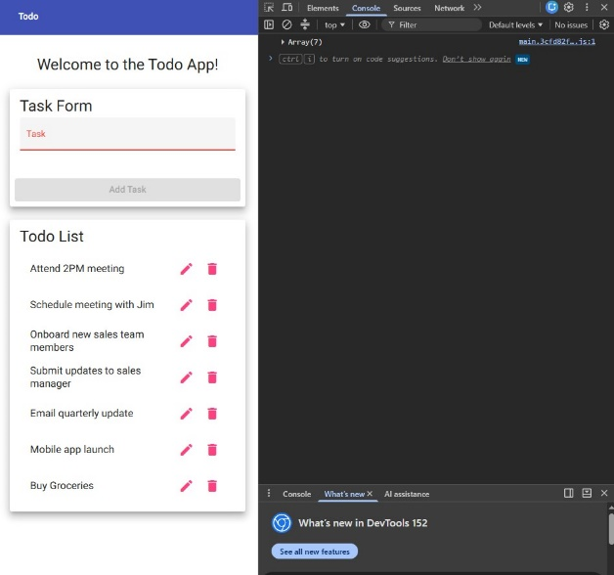
Comments | The add functionality worked smoothly. The new item appeared instantly and was properly formatted. This confirms the application meets the requirement for adding new todo items.

Test 3 | Mark Todo Item as Complete
 | Test Objective: Verify users can mark an item as completed | Developer: Girma  Date tested:  2026/09/03 | Peer tester: Ryan Barber  Date tested: 9/9/2026
Step | Action | Expected results: | Developer pass/fail | Tester pass/fail
1 | Add a new item | Item appears in list | Yes | Yes
2 | Click the checkbox next to item | Checkbox becomes checked | Yes | No
3 | Observe item styling | Item shows completed styling (strikethrough) | Yes | No  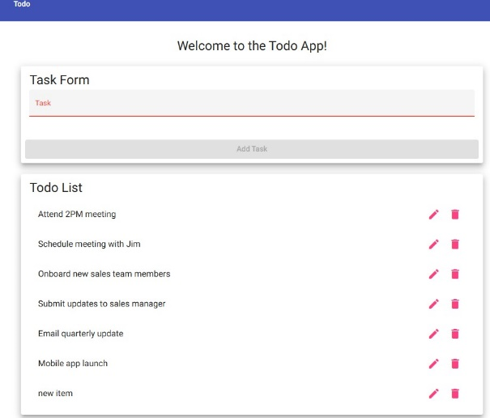
4 | Refresh page | Completed state persists | Yes | No  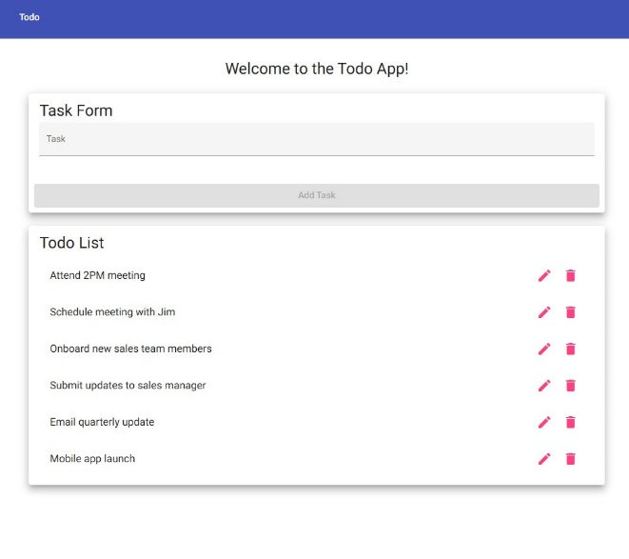
5 | Verify no errors | No console errors | Yes | Yes
Comments | Marking items complete worked as expected. The visual change was clear and persisted after refreshing, demonstrating proper state handling. This meets the business requirement for marking tasks complete.  Peer comment: There is no visible checkbox to mark item as complete.

Test 4 | Delete a Todo Item
 | Test Objective: Verify users can delete an existing todo item | Developer: Girma  Date tested: 2026/09/03 | Peer tester: Ryan Barber  Date tested: 9/9/2026
Step | Action | Expected Results | Developer pass/fail | Tester pass/fail  + Screenshot
1 | Add a new item | Item appears in list | Yes | Yes  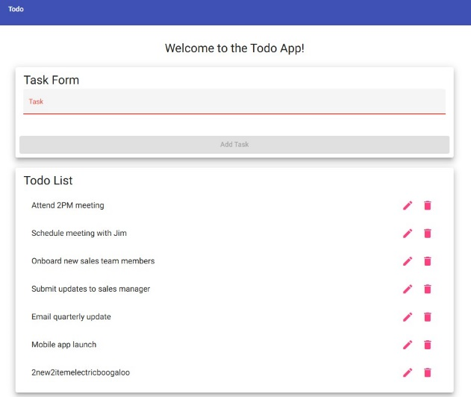
2 | Click the delete icon | Item disappears from list | Yes | Yes  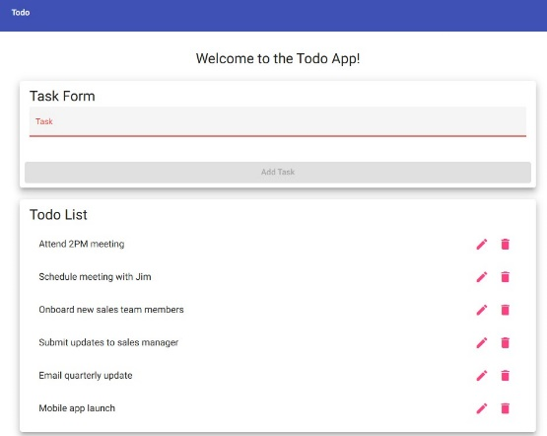
3 | Verify list updates | Remaining items shift correctly | Yes | Yes
4 | Refresh page | Deleted items do not reappear | Yes | Yes
5 | Verify no errors | No console errors | Yes | Yes
Comments | The delete function behaved correctly and removed the item instantly. The list updated without glitches, and the deleted item did not return after refresh. This confirms compliance with deletion requirements.

Test 5 | List Updates After Actions
 | Test Objective:  Verify the list updates correctly after adding, complete, and delete actions | Developer:Girma  Date tested: 2026/09/04 | Peer tester: Ryan Barber  Date tested: 9/9/2026
Step | Action | Expected Results | Developer pass/fail | Tester pass/fail  + Screenshot
1 | Add “Test update behavior” | Item appears in list | Yes | Yes  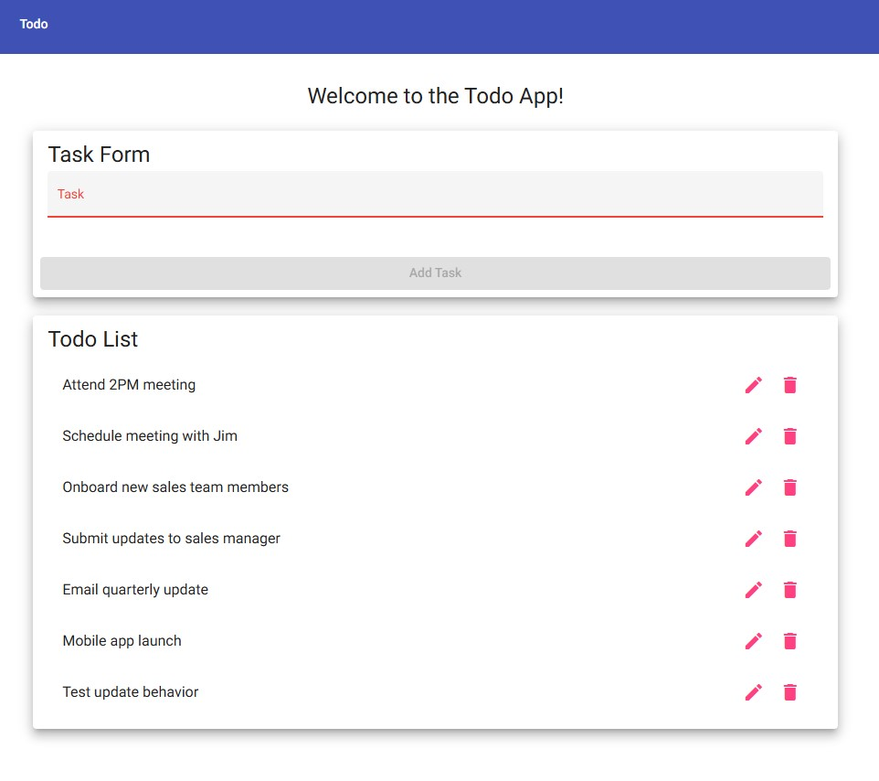
2 | Mark item complete | Item shows completed styling | Yes | No
3 | Delete item | Item is removed | Yes | Yes
4 | Verify list refresh | List updates instantly | Yes | Yes
5 | Refresh page | List reflects final state | Yes | Yes
Comments | The list updated correctly after each action, demonstrating stable UI behavior. The application handled multiple sequential operations without errors, confirming strong functional reliability.

